Ahinsadham CRM & ERP Platform
Detailed User Guide & Module Mapping
Document Title: | Ahinsadham CRM & ERP Module & Field Guide
System Local URL: | http://127.0.0.1:8000/
Author: | Ahinsadham CRM Development Team
Database Backend: | PostgreSQL (Ahinsadhamm)

1. Introduction to Ahinsadham CRM
Ahinsadham CRM is a comprehensive Customer Relationship Management and Enterprise Resource Planning platform built using Django and PostgreSQL. This document provides a step-by-step user guide covering how to log in, how to fill out various forms, what fields are available, where this data is displayed in tables, and how lookups/master data map to different fields in other modules.
2. System Authentication & Login
To log in to the portal, you must provide your authentication details on the login form:
- Fields to Fill on Login Form:
- Username: Your username (e.g., 'ahinsadham').
- Password: Your password (e.g., 'ahinsadham123').
Figure 1: Ahinsadham CRM Login Portal
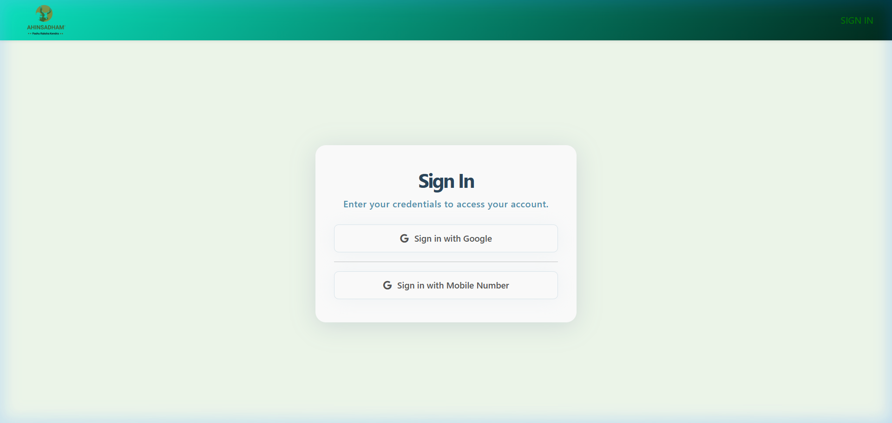

Access Restricted: You must have ahinsadham.org email address to access this feature.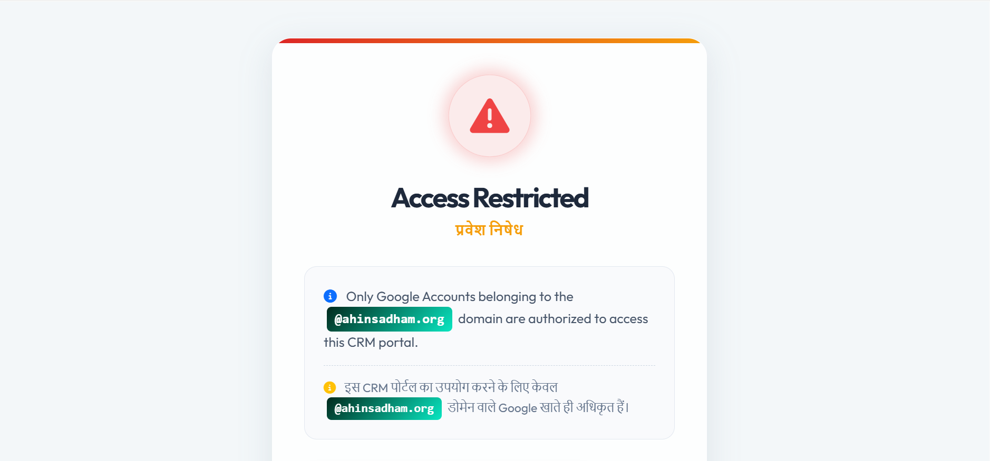

3. System Welcome Dashboard
Upon successful login, you will see the Welcome Dashboard. The left-hand sidebar contains links to the various operational modules depending on the permissions of your role. On the top header, the logged-in username is shown along with a Logout option.
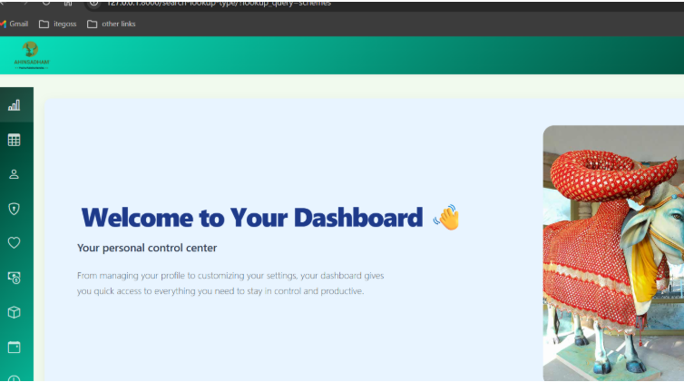
Where this data is displayed (Data Tables):
Figure 2: Welcome Dashboard
Field Name | Type / Options | Description & Lookup Mapping
Person Type | Dropdown | Mapped dynamically to the 'person_type' lookup (e.g. Donor, Volunteer, Donor-Box-Owner).
Salutation | Dropdown | Choices: Mr., Mrs., Ms., Dr., Shree, etc.
First / Middle / Last Name | Text | Personal identification fields.
Gender | Radio Buttons | Choices: Male, Female, Other.
Blood Group | Dropdown | Choices: A+, A-, B+, B-, AB+, AB-, O+, O-.
Contact & WhatsApp Number | Text | Telephone contact information.
Email Address | Email | Unique email address for correspondence.
Date of Birth & Age | Date / Integer | Date of birth and computed age.
Address Details | Text | Address, Area, City, State, Country, Postal Code.
Occupation Type | Dropdown | Mapped dynamically to the 'occupation_type' lookup (e.g. Service, Business).
Occupation Name | Text | Specific name of the organization or occupation.
Occupation Nature | Dropdown | Mapped dynamically to the 'occupation_nature' lookup (e.g. Medical, Engineering).

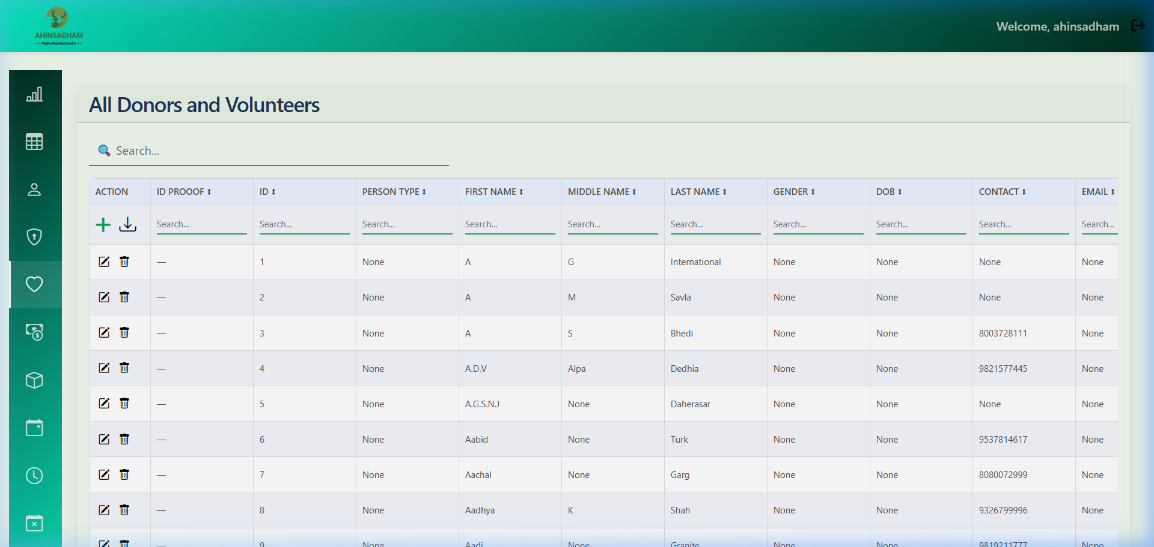
After clicking 'Submit', the saved data is displayed in the Donor & Volunteer List table on the dashboard or search pages. The columns shown in the data table include: Salutation, Full Name, Email, Contact Number, Native Place, and Action Buttons (Edit, Delete).
Figure 3: Add Donor and Volunteer Form
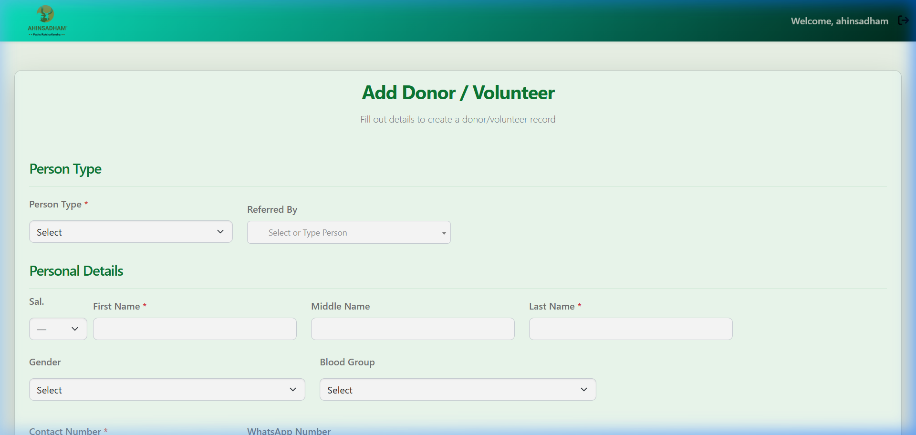

5. Master Data Management & Lookups
Master Data Management (MDM) allows system administrators to dynamically add options to dropdown lists throughout the CRM without changing code. The core lookup concept consists of two main tables:
- 1. Category (Lookup Type): The dropdown container name (e.g. 'person_type', 'occupation_type').
- 2. Subcategory (Lookup Table): The selectable items within that dropdown (e.g. 'Donor' inside 'person_type').
Figure 4: MDM Dashboard - Category and Subcategory Lists
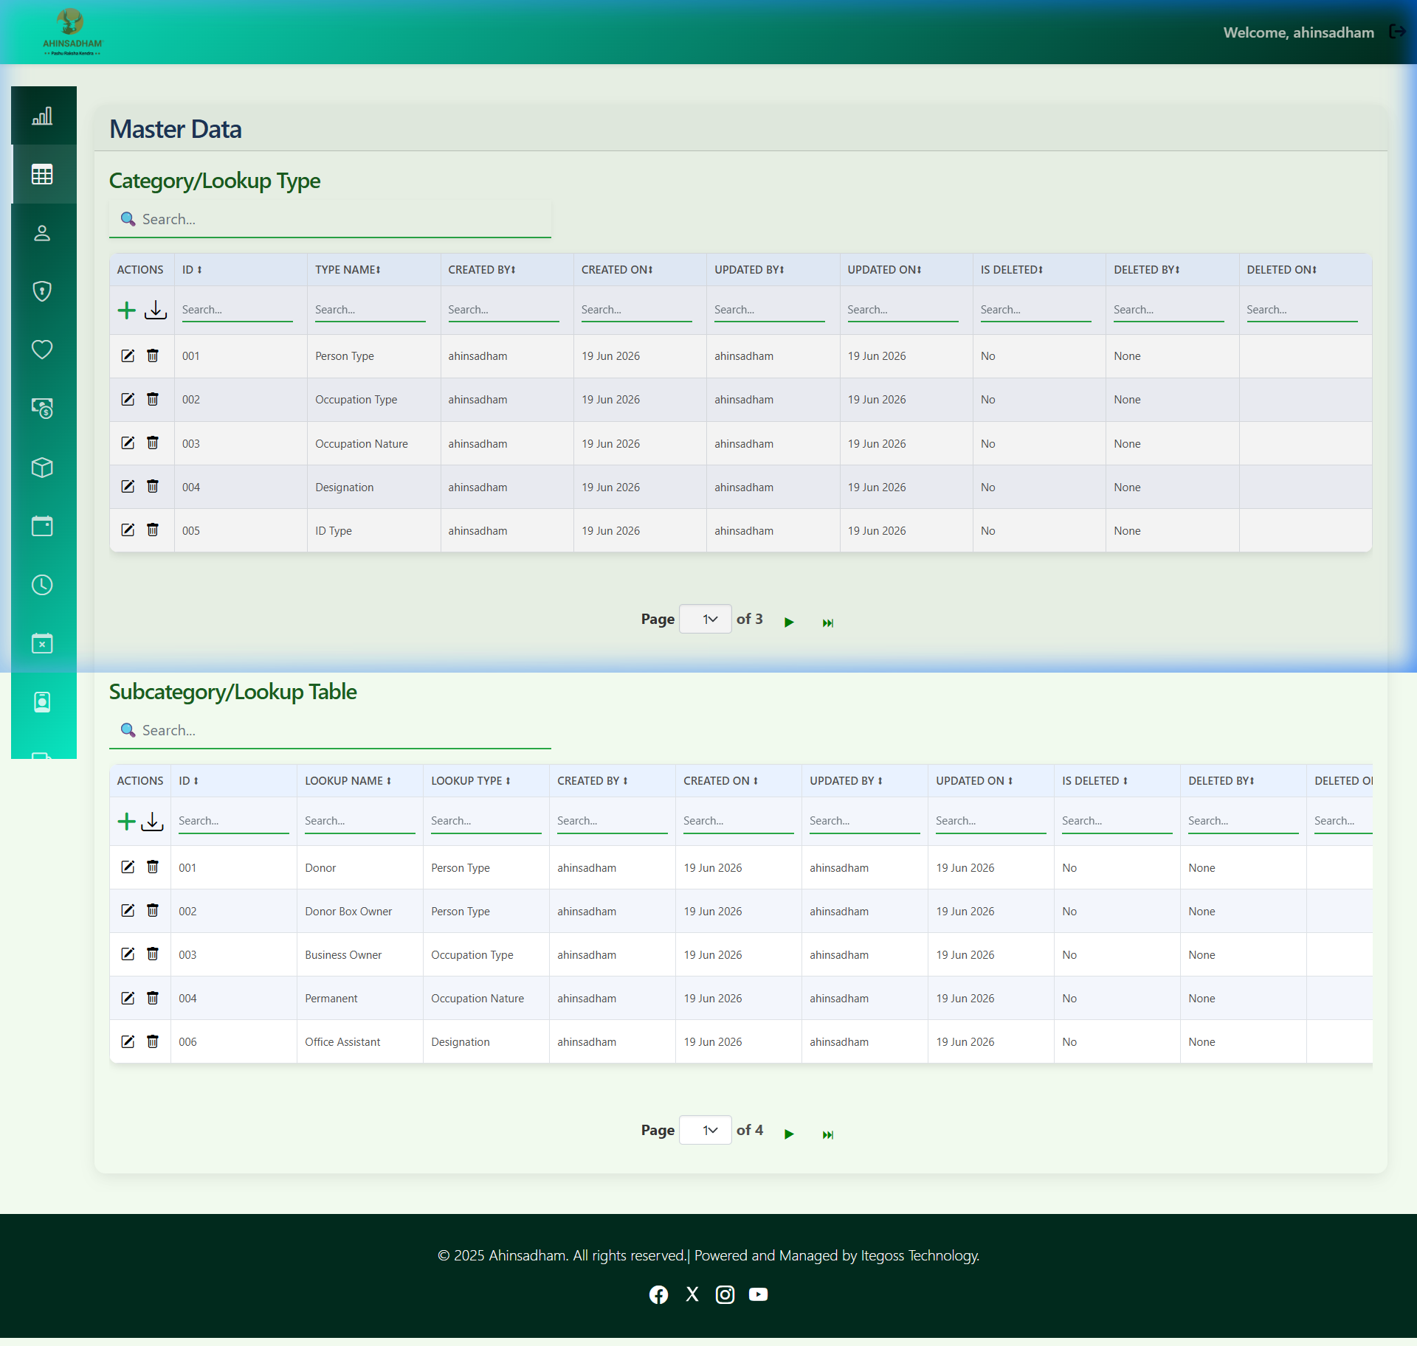
How to Add a Lookup value (Form):
- Fields to Fill on Add Lookup Form:
- Lookup Type: Select the category from the dropdown (e.g., 'occupation_type').
- Lookup Name: Type the display name for the new option (e.g., 'Social Worker').
Figure 5: Add Lookup Value Form

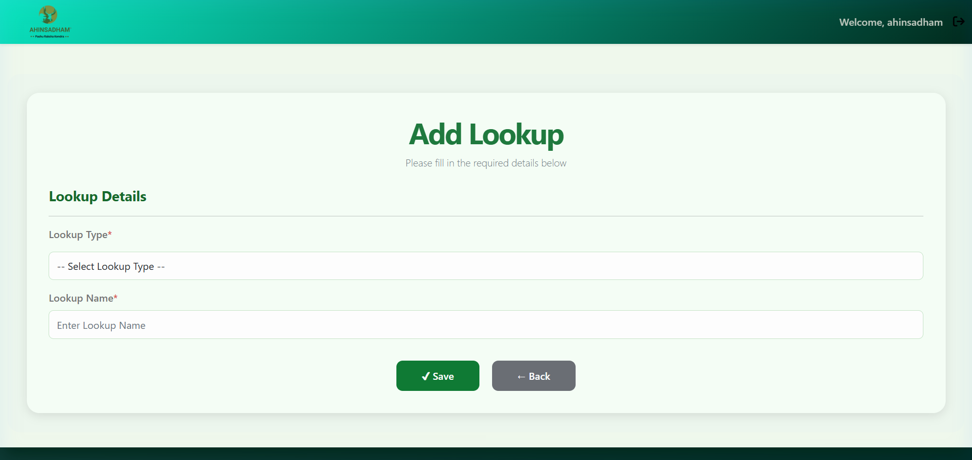
Where Lookup Fields Map & Display:
Whenever a new option is added in the Lookup form under a specific Lookup Type, it immediately shows up as a selectable choice in the corresponding dropdown on other forms. For example, if you add 'Physiotherapist' under the 'occupation_nature' Lookup Type, it will instantly be available for selection under the 'Occupation Nature' dropdown in the Add Donor/Volunteer form.

6. Role-Based Access Control (RBAC)
The Access Control panel allows mapping user roles to specific modules. Administrators can create permission matrices.
- Fields to Fill on Access Control Form:
- Module: Select the module to restrict (e.g., 'Donation Module').
- Role Name: Name of the role (e.g., 'Collector', 'Manager').
- Permissions Checkboxes: Toggle 'Can Access', 'Can Add', 'Can Edit', 'Can Delete', 'Can View'.

Where this data is displayed (Data Tables):
The mapping is displayed in the User Access Matrix table on the Access Control tab. Columns include: Module Name, Role Name, Access, Add, Edit, Delete, View, and Edit actions.
Figure 6: Role-Based Access Control Permissions Matrix

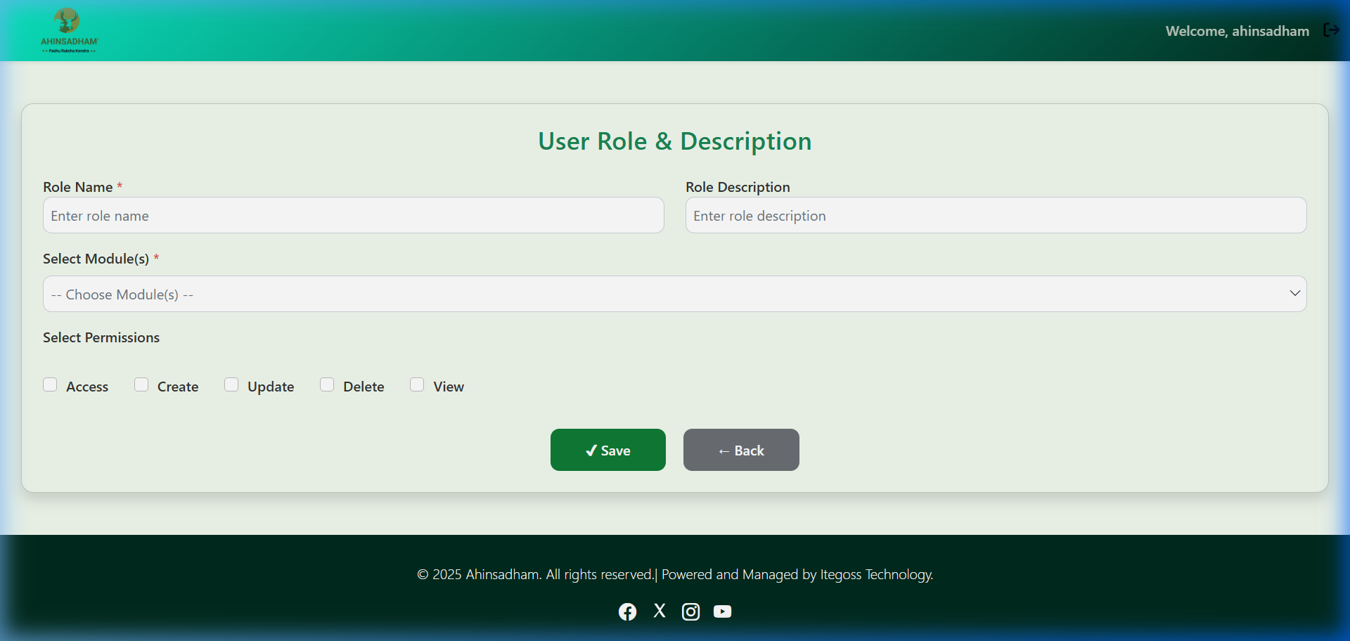

7. Donation Box Management
This module tracks physical collection boxes placed at donor locations. Setting up a new donation box automatically generates a tracking QR code.
- Fields to Fill on Add Donation Box Form:
- Box Size: Dropdown select (Small, Medium, Large).
- Box Owner: Text input for the owner of the premises where the box is placed.
- Box Percentage: Decimal field representing commission percentage (if any).
- Key ID: Text field to enter physical key identifier.
- Status: Dropdown select (Active, Inactive, Return).
Where this data is displayed (Data Tables):
Registered boxes are listed in the Donation Box List table. Columns shown are: Donation ID, Owner, Box Size, Percentage, Status, QR Code image, and Action Links.
Figure 7: Registering a Donation Box
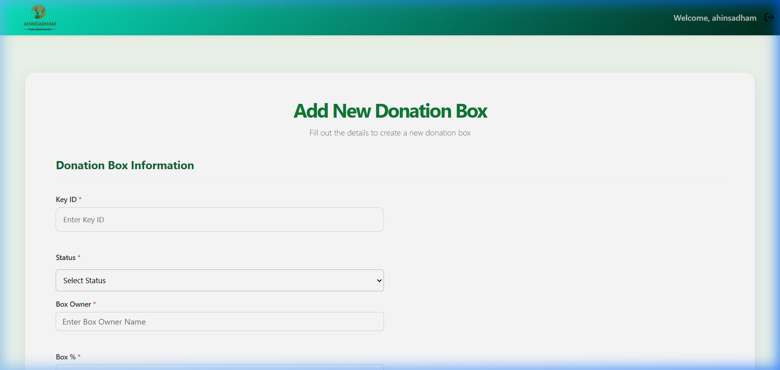

Schemes
If you go to the Schemes page, you'll find multiple donation schemes available. You can view them here: https://admin.ahinsadham.org/schemes/

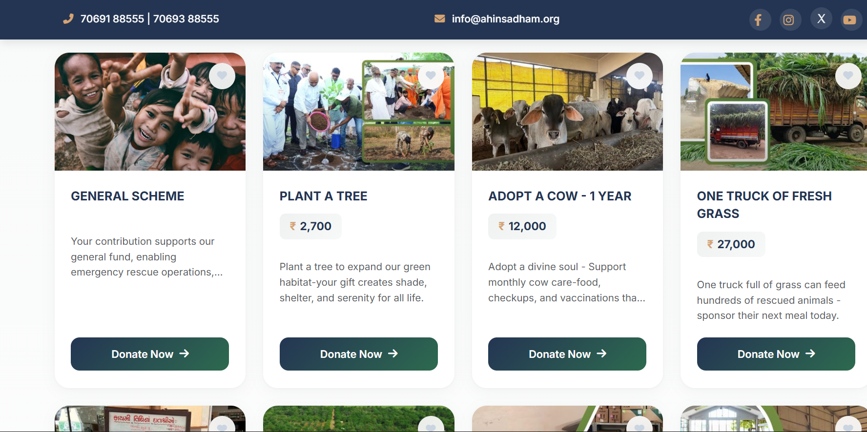

Go to the Schemes page, choose a donation scheme, fill out the donation form, and complete the payment through Razorpay. Once the payment is successful, the donation details will be added to the Donation module.
